OIL CONDITION MONITORING REPORT SLNA SAGARA

GEAR BOX PARTICULARS (Information provided by the customer)
 | Port | Stbd
Make : | RENK ELECON
Model : | PLS 71
Sr. No’s: | 679090 | 679091
Date sampling : | 01 Apr 25
Sampling point : | Lube Oil Sump
Sampling Method : | Extraction
Type of Lubricant : | Shell Gadinia S3 40
System Capacity : | 370 Ltrs

RUNNING HRS DETAILS (Information provided by the customer)
 | Port | Stbd
Sample ID | M009931 | M009932
Oil Running Hours | 903.48 | 684.29
Total Running Hours of the Machinery | 29473.43 | 29440.04

ANALYSIS RESULTS

Description | ASTM Method | Fresh Oil  (As per OEM datasheet) | Uncertainty | Port Gear Box (S/I-M009931) | Stbd Gear Box  (S/I-M009932)
Viscosity @ 40ºC (cSt) | ASTM D 445 | 128.00 | 0.006 Cst | 131.05 | 128.38
Viscosity @ 100ºC (cSt) | ASTM D 445 | 13.70 | 0.005 Cst | 13.77 | 13.53
Viscosity Index | ASTM D2270 | 103 | N/A | 101.05 | 100.42

Elemental Concentration as per ASTM D5185 (ppm)
Element | Maximum Permissible Limit | Fresh Oil Sample | Uncertainty | Port Gear Box (S/I-M009931) | Stbd Gear Box  (S/I-M009932)
Fe | 300 | < 1.000 | 0.15 | 4.564 | 3.374
Cr | 15 | < 1.000 | 0.18 | < 1.000 | < 1.000
Si | 50 | < 1.000 | 0.17 | < 1.000 | < 1.000
Al | 30 | < 1.000 | 0.28 | 1.923 | 1.921
Pb | 1500 | < 1.000 | 0.13 | 3.755 | 1.587
Cu | 250 | < 1.000 | 0.17 | 6.846 | 4.150
Sn | 50 | < 1.000 | 0.20 | < 1.000 | < 1.000
Ni | 30 | < 1.000 | 0.08 | < 1.000 | < 1.000

TREND ANALYSIS WITH PREVIOUS REPORTS

 |  | Fresh Oil Sample | Port Gear Box |  |  |  |  | Stbd Gear Box
 |  | Fresh Oil Sample | S/I-M000625 | S/I-M003034 | S/I-M003876 | S/I-M005810 | S/I-M009931 | S/I-  M000626 | S/I-  M001267 | S/I- M003035 | S/I- M004614 | S/I- M006387 | S/I-M009932
Oil Running Hrs |  | - | 2028.55 | N/I | 2000.00 | 218.15 | 903.48 | 2017.55 | 17.10 | N/A | 2000.00 | 77.10 | 684.29
T/R/H of Machinery |  | - | 26580.25 | 28299.50 | 28569.55 | 28788.10 | 29473.43 | 26524.15 | 26758.15 | 28236.25 | 28747.10 | 28832.45 | 29440.04
Basic Properties
Viscosity @ 40ºC (cSt) |  | 128.00 | 134.56 | 135.91 | 136.20 | 126.80 | 131.05 | 130.37 | 135.47 | 135.49 | 130.22 | 136.18 | 128.38
Viscosity @ 100ºC (cSt) |  | 13.70 | 13.89 | 13.46 | 14.11 | 13.58 | 13.77 | 13.68 | 14.19 | 13.41 | 13.82 | 14.28 | 13.53
Viscosity Index |  | 103 | 99.46 | 97.71 | 100.65 | 102.62 | 101.05 | 100.51 | 102.31 | 92.88 | 102.50 | 102.80 | 100.42
Elemental Concentration as per ASTM D5185 (ppm)
Element | Max. Permissible Limit
Fe | 300 | < 1.000 | 14.460 | 6.147 | 6.409 | 5.445 | 4.564 | 7.597 | 4.847 | 5.422 | < 1.000 | 1.747 | 3.374
Cr | 15 | < 1.000 | < 1.000 | < 1.000 | < 1.000 | < 1.000 | < 1.000 | < 1.000 | < 1.000 | < 1.000 | < 1.000 | < 1.000 | < 1.000
Si | 50 | < 1.000 | 2.861 | 1.041 | 3.037 | 11.829 | < 1.000 | 3.038 | 5.812 | < 1.000 | < 1.000 | 1.534 | < 1.000
Al | 30 | < 1.000 | 1.164 | < 1.000 | 1.070 | 3.702 | 1.923 | < 1.000 | 1.854 | 1.449 | < 1.000 | 2.288 | 1.921
Pb | 1500 | < 1.000 | 10.639 | 6.394 | 8.920 | 4.573 | 3.755 | 2.065 | < 1.000 | 1.436 | 15.760 | 1.435 | 1.587
Cu | 250 | < 1.000 | 6.247 | 6.001 | 5.141 | 4.903 | 6.846 | 2.468 | 1.597 | 3.790 | 1.681 | < 1.000 | 4.150
Sn | 50 | < 1.000 | < 1.000 | < 1.000 | < 1.000 | < 1.000 | < 1.000 | < 1.000 | < 1.000 | < 1.000 | < 1.000 | < 1.000 | < 1.000
Ni | 30 | < 1.000 | < 1.000 | < 1.000 | < 1.000 | N/A | < 1.000 | < 1.000 | < 1.000 | < 1.000 | < 1.000 | N/A | < 1.000

Wear Metals
Port Gear Box Stbd Gear Box
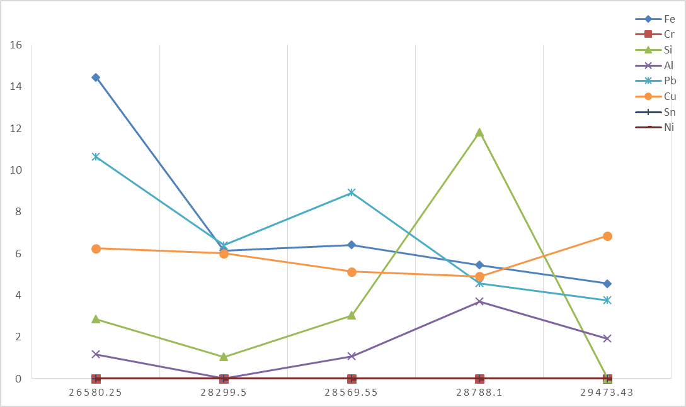
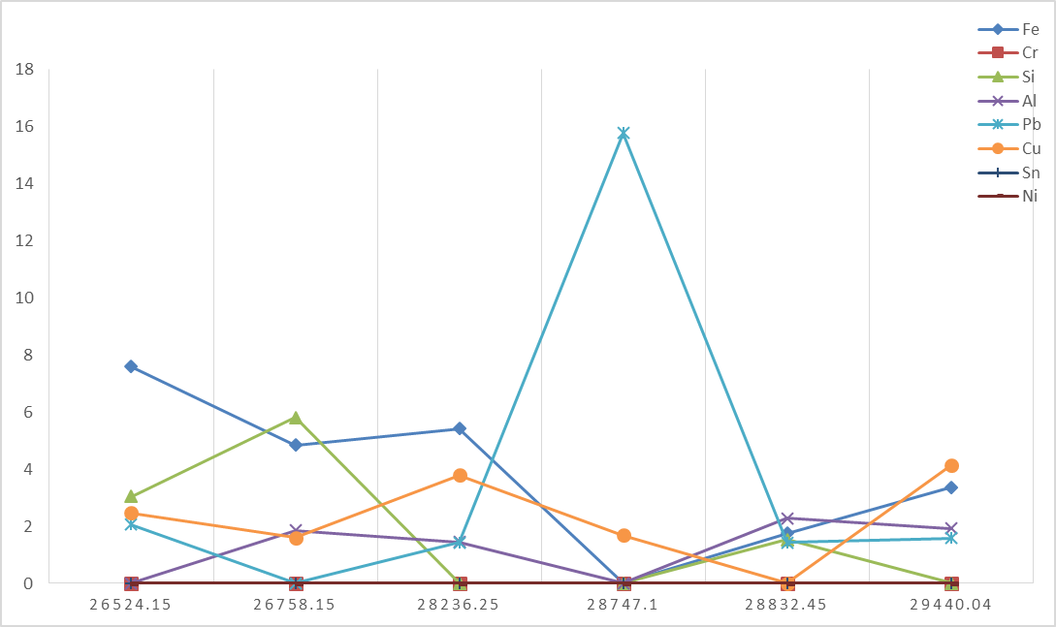

ppm
ppm

Total Running Hrs
Total Running Hrs

